**Main function:**

1. **Identify TF that regulate cell fate decision （或者有听起来更牛逼的说法改一下）**
2. **Identify sub-cluster based on TFs or GRPs from (1) (e.g. calculate cell score based on these TFs??)**

**Task1:**

**Identify TFs that regulate source state transfer to other state (The tf next to the legend is the ground truth)**

This atlas profiled hESCs infected with a lentivirus library to perform single TF overexpression in each cell, so we have ground truth.

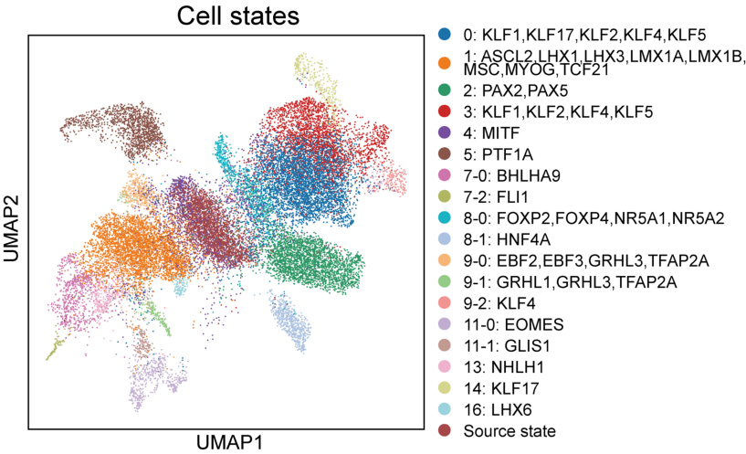

**Task2:**

**Identify TFs regulate progenitor cell reprogramming to reprogrammed cells.**

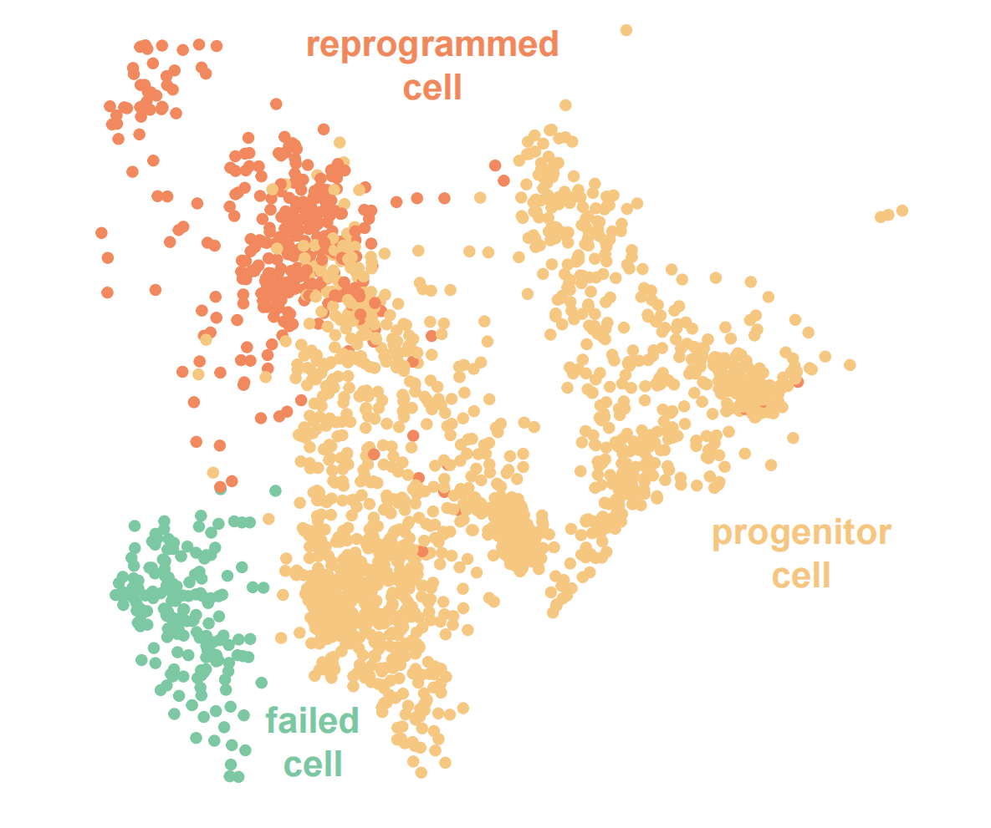

Then, based on the TFs or GRPs identified above, determine which progenitor cells will transition to reprogrammed cells (indicated by organ color below).

